FILE MEMORANDUM F/NWR-5
DATE: 1/29/2013
FROM: NOAA Fisheries
TO: FPOM BON Ops Task Group
SUBJECT: Model simulations of expected impacts to spring Chinook salmon through operation of B2 powerhouse to midrange and B1 Powerhouse to Best Operating Point

Introduction
Improvements to juvenile salmon survival in the gatewells at the Bonneville 2nd powerhouse (B2) can be expected through limiting the operation of B2 turbines to the midrange (FPC memo to task group 2012). Expected survival benefits have been estimated using a study that was controlled for gatewell debris and turbine load, where Gilbreath (2008) found that run of river Chinook salmon mortality in clean gatewells could be reduced from 4% to .5% when turbine operations were limited to the midrange. Additionally, significantly lower levels of mortality and descaling were found for subyearling Chinook in the gatewells from this operation, and benefits to sockeye juveniles are expected. Limiting B2 to midrange and transferring this flow to Bonneville powerhouse 1 (B1) is likely to improve conditions for juveniles, but could have negative impacts to spring Chinook and steelhead adults through increased fallback. Adult fallback, reascension, and conversion data is widely available at Bonneville through University of Idaho Radio telemetry studies and PIT reascension data (DART 2012). This memo uses this information in conjunction with adult count proportions and flow data (USACOE 2012) to model the expected impacts of limited B2 operation on spring Chinook salmon.

0 to 215 Kcfs River
- Spill 100K
- PH2 to Midrange of approximately 103K
- Miscellaneous of 12K
At these river flows, additional flow is not expected to go to B1 given the current priority and turbine outage scenario (no unit 11). Since no additional flow will go to B1, this operation should have no expected negative impact to adults through additional fallback. Since this operation is expected to improve conditions for juveniles, and will likely have no additional impact on adults, it is recommended.
235 Kcfs River
- Spill 100K
- PH2 to Midrange of approximately 103K
- Miscellaneous 12K
- PH1 20K
This operation results in 20 additional Kcfs that could have gone to PH2 under typical PH2 priority operation to the upper end of 1%. Under average conditions this shift in flow will shift 2% of adults to PH1 and a 1% additional fallback increase may occur. Model runs indicate this operation will be a benefit unless adult to juvenile ratios increase to 1 adult for every 10 juveniles (.1). Since this operation will improve conditions for juveniles, and these benefits are not outweighed by adult losses under normal return scenarios, it is recommended unless adult to juvenile ratios approach .1.
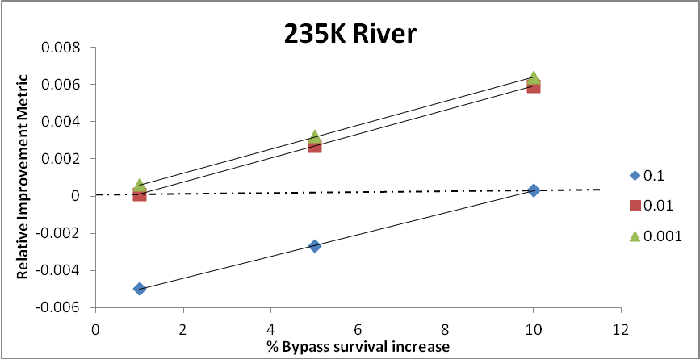
Figure 1. Model runs investigating the benefit of mid-point operation at Bonneville Dam PH2 at 235Kcfs river to increase juvenile survival considering impacts to adults with four different adult/juvenile proportion scenarios.
300 Kcfs River
- Spill 100K
- PH2 to Midrange of approximately 103K
- Miscellaneous 12K
- PH1 85K
This operation results in approximately 30 additional Kcfs that could have gone to PH2 under typical PH2 priority operation to the upper end of 1%. Under average conditions this shift in flow will shift adult attraction to PH1 and additional fallback may occur. Model runs indicate this operation will be a benefit unless adult to juvenile ratios increase to 1 adult for every 20 juveniles. Since this operation will improve conditions for juveniles, and these benefits are not outweighed by adult losses under normal return scenarios, it is recommended unless adult to juvenile ratios approach .05.

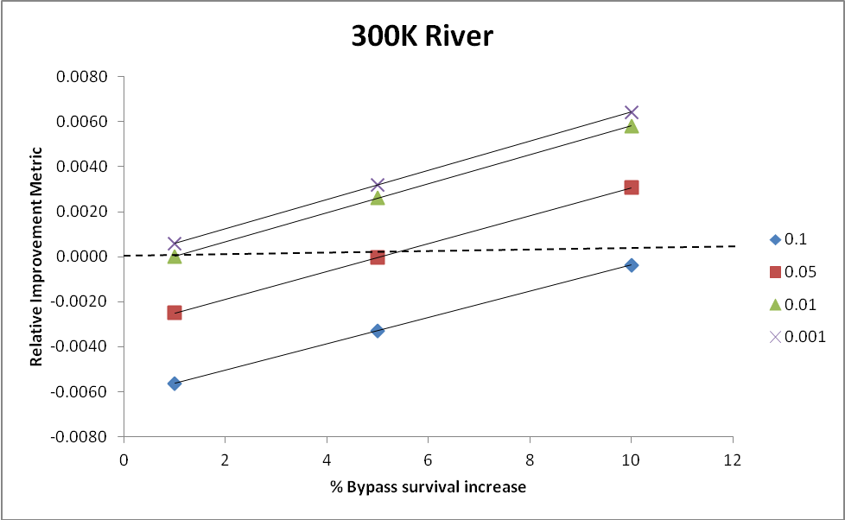
Figure 2. Model runs investigating the benefit of mid-point operation at Bonneville Dam PH2 at 300Kcfs river to increase juvenile survival considering impacts to adults with four different adult/juvenile proportion scenarios.

328 Kcfs River
- Spill 100K
- PH2 to Midrange of approximately 103K
- Miscellaneous 12K
- PH1 to BOP 113K
This operation is likely the worst case scenario for adults as it shifts the entire available 30 Kcfs from PH2 to PH1 max at best operating point. Under average conditions this shift in flow will shift adult attraction to PH1 and additional fallback may occur. Based on the information available, under average conditions this shift in flow will shift adult attraction to PH1 an additional 6% absolute and an additional 3% fallback may occur. This operation is recommended at these flows if adult to juvenile ratios are less than .01.

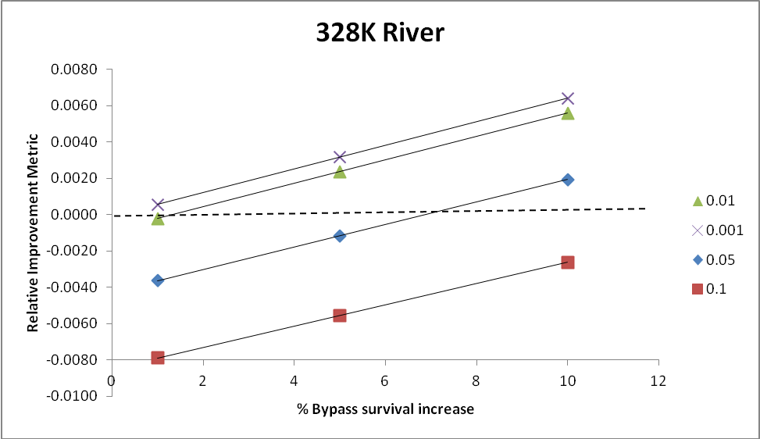
Figure 3. Model runs investigating the benefit of mid-point operation at Bonneville Dam PH2 at 328Kcfs river to increase juvenile survival considering impacts to adults with four different adult/juvenile proportion scenarios.
River Flow = 235
% Increase Bypass Survival | Adult to Juvenile proportion
 | 0.1 | 0.01 | 0.001
1 | -0.005 | 0.0001 | 0.0006
5 | -0.0027 | 0.0027 | 0.0032
10 | 0.0003 | 0.0059 | 0.0064
River Flow = 300
% Increase Bypass Survival | Adult to Juvenile proportion
% Increase Bypass Survival | 0.1 | 0.05 | 0.01 | 0.001
1 | -0.0056 | -0.0025 | 0.0000 | 0.0006
5 | -0.0033 | 0.0000 | 0.0026 | 0.0032
10 | -0.0004 | 0.0031 | 0.0058 | 0.0064
River Flow = 328
% Increase Bypass Survival |  | Adult to Juvenile proportion
% Increase Bypass Survival | 0.1 | 0.05 | 0.01 | 0.001
1 | -0.0079 | -0.0036 | -0.0002 | 0.0006
5 | -0.0056 | -0.0012 | 0.0024 | 0.0032
10 | -0.0026 | 0.0019 | 0.0056 | 0.0064

